Service Architecture
LP&I Service Naming and Service Taxonomy Standards

Version <1.1>
Document Control

Document Modification Control:
Date | Author | Role | Version | Comments
10/1/2011 | Catherine Ramsay | Technical Architect (Services) | 0.1 | initial revision based on LBG standards and LP&I naming discussion paper
2/3/2011 | Catherine Ramsay | Technical Architect (Services) | 1.0 | updated after PDA and peer review
11/5/2012 | Catherine Ramsay | Service SME | 1.1 | Added name length constraints and additional verbs and domains

Contents Page

1 CONTEXT OF THIS DOCUMENT 4
2 INTRODUCTION 4
2.1 Background 4
2.2 Rationale 5
2.3 Expected updates 5
2.4 Principles 5
2.4.1 Common vocabulary and Data Definitions 6
2.4.2 Services must be designed for Re-use 6
2.4.3 Compose coarse grain 6
2.4.4 Service must be Generalised 6
2.5 Service Operation Granularity 6
3 NAMING GUIDELINES 7
3.1 Service Naming 7
3.2 Service Operation Naming 8
3.3 Service Object Naming 9
3.4 General guidelines and rules 9
3.5 WSDL Granularity 10
3.6 WSDL Naming 10
3.7 XSD Naming 10
4 GLOSSARY 11
5 APPENDICES 12
5.1 Common Information Model (CIM) Domains 12
5.2 Service Domains 13
5.3 Key Verbs 13

CONTEXT OF THIS DOCUMENT
The following document describes the naming standards for Services within Life Pensions and Investments (LP&I) within Lloyds Banking Group (LBG) in the context of Service Orientated Architecture (SOA). This document is complementary to the existing standards already published within LBG. This document should be used within LP&I instead of the LBG standards. http://transwss.lloydstsb.co.uk/sites/soasr/SOAP Documents/LBG Service Naming Standards v09.doc

INTRODUCTION

Background
This document is a guideline for Projects / Service Providers within LP&I that are responsible for designing and developing Services. It is based on the LBG standards document. http://transwss.lloydstsb.co.uk/sites/soasr/SOAP Documents/LBG Service Naming Standards v09.doc
The OASIS definition of a Web Service is:
‘A Web Service is a software component that is described via WSDL and is capable of being accessed via standard network protocols such as but not limited to SOAP over HTTP.’
Reference: www.oasis-open.org/committees/wsia/glossary/wsia-draft-glossary-03.htm
These naming guidelines apply to all types of Services as described below (but this needs updated to refer to the Service Classification document, as and when it becomes approved)
Business Service
A Business Service exposes operations that are centered round an important resource the Bank needs to keep track of. It is a Logical view of business data and business logic aligned and in context to the Banks Capability Model. Business Services are consumed by Consumers and/ or Process Services.
Process Service
A Process Service corresponds to an ‘end to end’ business process and provides the control capabilities required to manage the flow and interaction of multiple services in ways that implement business processes. Process Services are consumed by Consumers and/ or other Business Processes e.g. Process Automation services.
Utility / Technical Service
A Utility Service performs common technical or non business “sub-routines”, needed within several other services. Utility Services are consumed by Consumers, Business Services and/or Business Processes e.g. DOC1 print service.
Underlying/ Wrapped Service
An Underlying/ Wrapped Service provides bridging capabilities to incorporate interfaces/ API’s that are delivered through existing applications. These Services are consumed by Business Services and never directly by the Consumer. This type of Service covers the majority of Services used within LBG providing the back end functionality in the ‘Systems of Record’ layer. These are usually fine grained offering specific functionality e.g. wrapped services defined by OCIS and CBS.
This positioning of these services is illustrated in the diagram below:

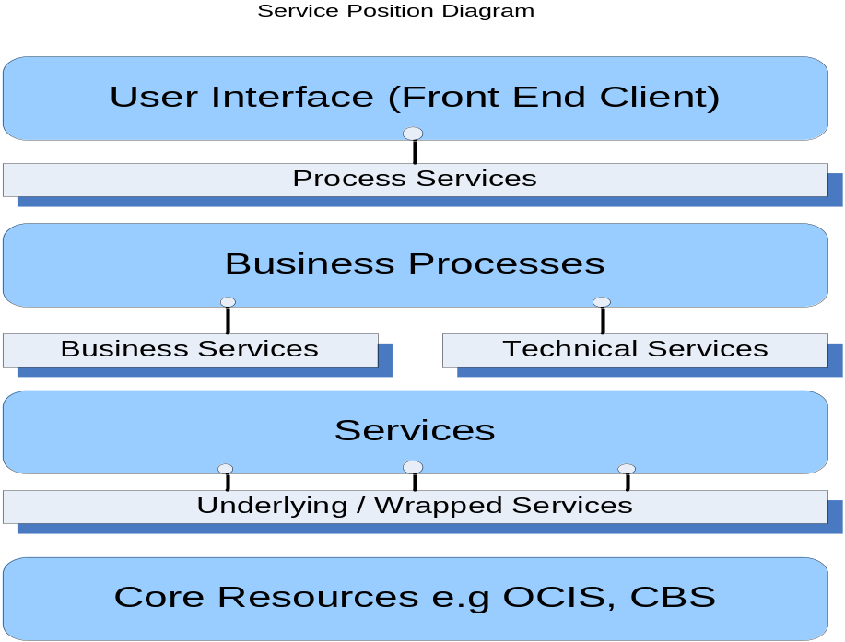
Service positioning diagram

Rationale
The use of a consistent taxonomy for naming Services and related types will ensure uniformity and quality across LBG service estate that drives simplicity, aids discoverability; increases re-use and reduce risk and cost to the company.
Heritage Scottish Widows standards have evolved over time before they were part of the Lloyds TSB Group, and services named using these standards are prevalent across LP&I, and are already used on Sonic, the LP&I Strategic ESB. LP&I have made the decision to diverge in places from the LBG guidelines. To continue with the heritage Scottish Widows standards (or standards evolved from them) will enable consistency across LP&I for new services.

Expected updates
This version defines the standards for existing SW Legacy ESB services and initial Sonic ESB services. A new Common Message Model is being investigated and updates are expected in response to that.

Principles
The following Web Service Principles (as documented in the Web Service Policy http://transgroupspace.lloydstsb.co.uk/sites/EAD/LEAF/LBG%20IT%20Policy%20Refresh/LBG%20IT%20Web%20Services%20Policy.doc ) govern the Service Contract design but has a specific impact on the naming applied to the a Service. It must be noted that not all services are exposed as Web Services: Sonic processes can be invoked by Adaptris, however the principles remain the same.

Common vocabulary and Data Definitions
Data is defined consistently throughout the LP&I Enterprise through the use of and reference to the LP&I Common Information Model (CIM) and the definitions are understandable and available to all users. (LBG has a Common Service Model.)
The names of services and operations must be recognisable by people with little or no technology awareness, and must use business concepts rather than technical jargon. They must be understandable by functional (not technical) domain experts.
Service parameters must use Enterprise Data Definitions and reuse XML schemas (XSD) and fragments, aggregating and/or elaborating these into larger schema definitions required by the service. Reuse of schema definitions promotes consistency in the way that business objects are represented in XML.
Moreover, the granularity of the parameters must reflect logical groupings.
Services and parameters must be generalised where possible though polymorphism. This will ensure multiple 'similar' concepts can be handled as input or output of a service ensuring the contract of the Web Service is less brittle.

Services must be designed for Re-use
Where possible, services must be designed to be reusable by multiple business processes and/or Consumers. This involves consideration of other potential usage contexts in addition to the one that the service is initially developed. Even if the requirements aren’t yet known, the design may be able to mitigate to allow easier extension/enhancement later on.
Through the use of and/ or reference to CIM, potential services can be identified.

Compose coarse grain
Generalised, coarse grained services must be defined to match requirements of business applications. These must be constructed from Fine Grained Services

Service must be Generalised
Service and its operations must be generalised thus allowing the service to be used in new and unforeseen contexts.

Service Operation Granularity
The following decision tree should help guide projects to the level of granularity and type of Service required:

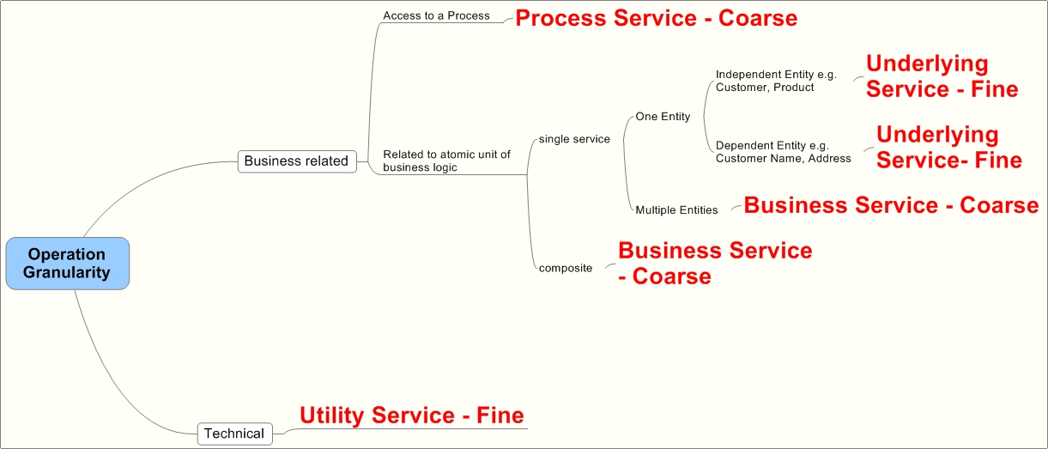

NAMING GUIDELINES
The following guidelines will help in making the right decision when naming Services and their operations:

Service Naming
The Service itself is named depending on the type of Service but follows the same pattern:

prefix + Object / CIM Domain + “Service”

Naming convention: Names are shown in non-proportional characters; the first letter of the name is in upper case, the first letter of each new word within the name is in upper case, with no spaces between the words.
- Process and Business services encapsulate process and business logic and are mostly coarse grained and composite. In this case, the thread that ties together the grouped operations is a specific set of related functionality performed on a specific domain or object being automated by the service logic.
The prefix represents the product group:
General
Investment (covering functionality that is specific to investment products including pensions, e.g. assets, valuations)
Pension (covering functionality that is specific to pension products)
Protection
Product group is used to easily identify which services and functionality are relevant to which products, and can be used to aid decisions about physical implementation.
We generally use the CIM Domain in order to name the service but there are some exceptions to this. Lifecycle is taken into account where the lifecycle is deemed to be relevant or the business logic is significantly different, or to group similar functionality where it is performed on different domains, e.g. underwriting for a protection application could be for a plan or a policy. See 5.2 Service Domains for a full list of service objects / domains.
Examples of Services are as follows:
ProtectionUnderwritingService
GeneralPolicyService
GeneralAgencyService
InvestmentPlanService
- Utility services (also known as Technical services) involving operations that encapsulate cross-cutting functions, such as event logging, exception handling, or notification. These reusable services need to be labeled according to a specific processing context, agnostic in terms of any particular solution environment. The naming of a Utility service depends on whether or not it is performing functionality on a CIM object / interfaces are defined in CIM format. The prefix is always “Technical”. If the service is for a CIM object then it is named after the CIM Domain, as for Process and Business services.
e.g. TechnicalContact could provide functions such as SendEMail, SendFax and other Contact domain related functions, and these will be reused in various Process and Business services as required.
Utility Services can also be used to group operations that are platform specific or not reusable and designed for a specific purpose. Enrichment is a good example of this, where certain information is required by a consumer to fulfill a business function where information is held across multiple platforms or databases.
e.g. TechnicalPolicy could provide an enrichment operation to be consumed by ALIS Pension to complete a projection where all information is not stored on ALIS.
Examples of non-CIM utility services have yet to be identified. Naming standards will be defined when required.
- Underlying/Wrapped services are not exposed as web services. In Sonic, these are realised as Sonic processes. Link to be added when document for naming standards for these is complete.
Note, SW Legacy ESB and some ESI services do not conform to this standard; they have “Svc” suffix.

Service Operation Naming
A Service operation is always named with an active voice, imperative mood verb plus an object noun on which it operates.

verb + ObjectNoun

Naming convention: Names are shown in non-proportional characters; the first letter of the name is in upper case, the first letter of each new word within the name is in upper case, with no spaces between the words.
Examples of Service Operations are as follows:
AddPensionQuote
GetClientList
GetPolicyDetails
UpdProposal
The maximum length for an operation name is 25 characters, due to size restrictions in files and code artifacts.
The list of verbs for Process and Business services is more restricted than for Utility services. The following are an example of Verbs: Add, Get, Upd(ate), Del(ete), Val(idate). See 5.3 Verbs for full list of acceptable verbs. Verbs are shortened as standard.
Object Noun must be in line with CIM. See 3.3 Service Object Naming and 3.4 General guidelines and rules. Object nouns can be shortened if required (to meeting length constraints). See 5.4 Object abbreviations for a list of acceptable abbreviations.
These rules also apply to non Web Service components that are exposed via Adaptris.

Service Object Naming
A Service object (Complex Type) may be as specific as necessary to convey the meaning of the business requirement, however making it more generic will contribute to building more reusable services. The Object name is determined using the Objects defined in the CIM.

ObjectNoun

Naming convention: Names are shown in non-proportional characters; the first letter of the name, as well as the first letter of each new word within the name is in upper case, with no spaces between the words.
For example: <ContactDetails>. If we have a requirement to retrieve contact details for a party, then the Object it maps to is <ContactDetails>. This is generic as it reflects all types of Contact Details (e.g. address, phone number, email address) and when new types of contact details are defined then we do not require a new service operation.
Object Noun must be in line with CIM. However, there are some subtleties to naming dependent on the type of operation. If the service is retrieving attributes of a parent object or high level details then the ObjectNoun should be suffixed with “Details”. For additions and updates the object itself is named without any suffix. If we are retrieving, adding, updating or deleting more specific details of an association or sub-type /object then the ObjectNoun should reflect that.
e.g.
GetPartyDetails returns details of a Party including name and date of birth, but not child objects like Contracts
GetPartyContractList returns a list of Contracts (plans and/or policies) related to a specific Party
UpdProposal updates the details of a proposal, e.g. start date
GetProposalDetails retrieves information about a proposal
AddPolicyTrade adds a trade for a specific policy
See 5.4 Object abbreviationsfor acceptable object abbreviations.

General guidelines and rules
- A “List” suffix indicates more than 1 Object (or set of Objects) can be returned, the details are high level and additional operations should be called to retrieve full information for the Object
For example:
GetPolicyList - returns an array [0..*] of Policy complex types which are populated with summary information
GetPolicyDetails – returns details for [0..1] Policy complex type
GetOccupations – returns an array [0..*] of Occupation complex types and full details are returned
- Do not to use Project or System names in the Services or Operations. The exception to this being System names in Utility operation names where appropriate.
- Avoid using prepositional phrases in Service object names. Be more descriptive in the Service details / definition to show where or why or how a Service has moved the business in order to produce an output, rather than including words like: for, by, with, to, from, over, through, in, etc. in the Service name. Utility Services can have exceptions to this rule.
For example: getPolicyValuation rather than getValuationForPolicy, getPartyContactDetails rather than getContactDetailsForParty
- Do not use gerunds (verbs ending in “ing” that are used as nouns) in the Service operation object names.
For example by adding “ing” to a verb it can become a noun and be used an Object: e.g. monitorEvent rather than activateMonitoring

WSDL Granularity
According to the W3C specifications a WSDL can theoretically contain multiple services, and each service can contain multiple operations (methods). Similar an Component can contain multiple Interfaces (Services).

However, only 1 Service per WSDL will be allowed. The definition of “service” in SOAP terms is however, different to what we may have used in the past. A Service DOES NOT equal an individual API. Rather, a Service operation is likely to map to an API.

WSDL Naming
The name of the WSDL should reflect the name of the Service, “Service” plus the WSDL file extension e.g. GeneralPolicyService.wsdl

ServiceName + Service.wsdl

Naming convention: Names are shown in non-proportional characters; the first letter of the name, as well as the first letter of each new word within the name is in upper case, with no spaces between the words. Suffix is always “Service.wsdl”.
Note, SW Legacy ESB and some ESI services do not conform to this standard; they do not contain the “Service” suffix or have “Svc” suffix and in some cases are missing the “General” Service name prefix.

XSD Naming
The name of the XSD defining the Service interfaces should reflect the Service Name, plus the implementation of the Service. If it is defining a Web Service interface then it should have the suffix “Service”; if it is defining a non Web Service interface then it should have the suffix “Interface”, e.g. GeneralPolicyService.xsd, TechnicalPolicyInterface.xsd

ServiceName + ImplementationType.xsd

Naming convention: Names are shown in non-proportional characters; the first letter of the name, as well as the first letter of each new word within the name is in capitals, with no spaces between the words. Suffix is always “.xsd”.
Note, SW Legacy ESB and ESI services do not conform to this standard; they use the suffix “Svc” instead.

GLOSSARY
Term | Description
Adaptris | TO DO get definition
Business Service | A Business Service exposes operations that are centered round an important resource the Bank needs to keep track of. It is a Logical view of business data and business logic aligned and in context to the Banks Capability Model.  Business Services are consumed by Consumers and/ or Process Services.
CIM | LP&I Common Information Model, common definitions of message objects  http://eadentrepprod.scottishwidows.com/EADINFMOD/index.html
Noun | A word or a group of words that refers to a person, place or thing.
OASIS | Organisation for the Advancement of Structured Information Standards – a consortium for the development of e-business standards.  OASIS Standards are approved within an OASIS Committee, submitted for public review, implemented by at least three organizations, and finally ratified by the Consortium's membership at-large
Process Service | A Process Service corresponds to an ‘end to end’ business process and provides the control capabilities required to manage the flow and interaction of multiple services in ways that implement business processes.  Process Services are consumed by Consumers and/ or other Business Processes.
Service Provider | Creates and publishes a service for consumer use.
Service Consumer | Requests the execution of a service
SOAP | Simple Object Access Protocol - a way for a program running in one kind of operating system, e.g. Windows to communicate with a program in the same or another kind of an operating system, e.g. UNIX using HTTP and XML.
Sonic | Enterprise Service Bus from Progress Software which supports messaging and event-driven interaction and integrates systems via course grained business services & technical services / components. Simplifies the integration and flexible reuse of applications within an SOA.
Underlying/ Wrapped Service | An Underlying/ Wrapped Service provide bridging capabilities to incorporate interfaces/ API’s that are delivered through existing applications.  These Services are consumed by Business Services and never directly by the Consumer.
Utility Service | A Utility Service performs common technical or non business “sub-routines”, needed within several other services.  Utility Services are consumed by Consumers, Business Services and/or Business Processes.
Verb | A verb is a word that usually denotes an action.
Web Service | LBG uses the W3C definition of a Web Service which is:  "A Web service is a software system designed to support interoperable machine-to-machine interaction over a network. It has an interface described in a machine-processable format (specifically WSDL)."  The remainder of the definition refers to a specific Binding type and so is not included in the LBG meaning of the term "Web Service". For reference this is:  "Other systems interact with the Web service in a manner prescribed by its description using SOAP messages, typically conveyed using HTTP with an XML serialization in conjunction with other Web-related standards."
WSDL | Web Services Definition Language- the standard used to define a Web Service in XML, and used by the consumer, provider and proxy to ensure consistency of interface and interoperability.
W3C | World Wide Web Consortium – standards body created to define common protocols for use on the Internet.  A W3C Recommendation is a specification or set of guidelines that, after extensive consensus-building, has received the endorsement of W3C Members.  A Proposed Recommendation is a mature technical report that, after wide review for technical soundness and implementability, W3C has sent to the W3C Advisory Committee for final endorsement
XML | eXtensible Markup Language – Industry standard self-defining message format used as the basis for LBG messaging.
XSD | XML Schema Definition – W3C recommendation that specifies how to formally describe the elements in an XML document.

APPENDICES

Common Information Model (CIM) Domains
This list is as-is, new Common Message Model Domains to be defined in a later revision.
- Agreement – agreements, involvements and associated classes
- AntiMoneyLaundering – can be shortened to AML
- BusinessEvent – sub domain of Event
- Commission – deprecated, newer classes in Remuneration
- Contact – all contact classes and associated classes, e.g. Addresses, Email, Telephone
- Document
- Event – events and transactions
- Intermediary – intermediaries and agencies
- Investment – classes that are common to investment products including pensions
- Marketing
- Party – parties, persons and organisations and associated classes
- PartyRelationship
- PaymentArrangement
- Payments – payments in / contributions and payments out
- Pension
- Plan – plan contract classes and associated classes
- PolicyCollection
- Product – policy contract classes and associated classes
- Protection
- Remuneration
- Scheme
- Security
- Servicing
- StandardTypes – common and simple types
- StandardValues – all enumerations
- Tracking – proposal and associated classes
- Underwriting – underwriting and associated classes, not contract specific, e.g. used for plans and policies
- Valuation

Service Domains
This section details exceptions to service names where they are not named after CIM Domains. It is based on the CIM.
- Agency – used for services that manipulate Agency objects (in Intermediary domain)
- Asset – these classes are currently split over Investment and Valuation
- Event – also used for sub domain BusinessEvent
- Policy – this is used instead of Product

The following lifecycle names are used in Service naming instead of the object:
- Quote – for new business quotations, this covers both Plans and Policies
- Application – for new business applications, this covers both Plans and Policies
- Tracking – for new business proposal tracking

Note that Quote and Application are deemed to be significantly different for the various product groups and are specific to a Product group, e.g. ProtectionQuote, PensionApplication.
The following domains should not be used in service names:
- Supporting type domains like Commission and Marketing (Utility Services being the exception)
- StandardTypes
- StandardValues
- Valuation – this domain covers projections and valuations. Use relevant contract domain instead, i.e. Plan or Policy

Verbs
Business/Process Services:
- Add
  - synonyms include Create, Start, Initiate
  - for adding up, use Calculate
- Get
  - synonyms include Retrieve, Access, Read
- Upd(ate)
  - synonyms include Amend, Change, Modify
  - for transactional related activity, use this for authorisation/approval/rejection (update the transaction)
- Calc(ulate)
  - don’t often use this, admin systems tend to calculate and store, so use Add or Upd instead usually
- Del(ete)
  - transactional – safely delete something and we don’t need to keep knowledge of that, would normally be used for deleting something incomplete and/or unauthorised. See also Cancel and Reverse.
- Can(cel)
  - synonyms include Abandon
  - transactional – cancel something that we don’t want to do anymore but want or need to have knowledge of, would normally be used for cancelling a pending transaction. See also Delete and Reverse.
- Reverse
  - transactional – reversing a transaction that has been completed. See also Delete and Cancel.
- Assign
  - task and role related
- Action
  - for Process services, e.g. ActionUnitAdjustment
  - synonyms include Process.
Technical/Utility Service can use verbs as per Business/Process Services plus:
- Acq(uire)
  - come into possession of and hold onto something, e.g. get/retrieve and store data
- Val(idate)
  - for utility services, reusable component to validate a particular part of something, would be called from Add and Update business services, e.g. ValBankAccountDetails validates a bank account and sort code combination, could be used in new business and payment services
- Notify
  - notify an application/system that an event has occurred, e.g. a policy has gone on risk in ALIS P4L, Client holds policy statuses and is notified.
- Submit
  - submit a file or record or return to a 3rd party, e.g. HMRC
- Trigger
  - to trigger a service or process in one application/system based on an event occurring (could be time event or event in another application/system), e.g. TriggerLeadWorkflow is triggers lead workflow processing
- Ack(nowledge)
  - acknowledge something has happened, would normally be used in asynchronous messaging
- Authenticate
  - used by client applications to authenticate users on various security systems
- Send
  - send a document or message in a particular medium/format, e.g. SendEMail
- End
  - synonyms include Terminate, Complete
  - used to end relationships (e.g. involvements, agreements)

Object abbreviations
As a general rule, you can abbreviate an object by using the first few letters of the object name or by removing vowels. It should be easily recognisable and understandable.

- Advsr - Adviser
- Ann(uity)
- Appl(ication)
- Ben(efit)
- Chrg – Charge
- Contrib(ution)
- Doc(ument)
- Emp(loyed)
- Empee – Employee
- Emper - Employer
- Ext(ernal)
- Id(entifier)
- Incr(ement)
- Inv(estment)
- Mort(gage)
- Pen(sion)
- Pay(ment)
- Pol(icy)
- Prot(ection)
- Ref(erence)
- Regn – Registration
- Schm - Scheme
- Trans(action)

UpperCamelCase
Definition: ”Verbs in the active voice show the subject acting”
Definition: “Verbs are in the imperative mood, which expresses commands or requests”
UpperCamelCase
UpperCamelCase
UpperCamelCase
UpperCamelCase

